Progression of knowledge and vocabulary: Design and Technology 
Reception
 |  | Autumn Term | Spring Term | Summer Term
 |  | Structures: Designing and making a junk box boat  https://www.kapowprimary.com/subjects/design-technology/reception/reception-units/structures-boats/ | Cooking and Nutrition: Soup  https://www.kapowprimary.com/subjects/design-technology/reception/reception-units/food-soup/ | Textiles: Bookmarks  https://www.kapowprimary.com/subjects/design-technology/reception/reception-units/textiles-bookmarks/
Skills | Design | Making verbal plans and material choices.  Developing a junk model.  Designing a junk model boat.  Using knowledge from exploration to inform design.  Designing a junk model boat. | Explore and taste different fruits. Choose favourites. | Discussing what a good design needs.  Designing a simple pattern with paper.  Designing a bookmark.  Choosing from available materials.
Skills | Make | Improving fine motor/scissor skills with a variety of materials.  Joining materials in a variety of ways (temporary and permanent).  Joining different materials together.  Describing their junk model, and how they intend to put it together. | Children wash hands, prepare fruit using child-safe utensils, and assemble salad. | Developing fine motor/cutting skills with scissors.  Exploring fine motor/threading and weaving (under, over technique) with a variety of materials.  Using a prepared needle and wool to practise threading.
Skills | Evaluate | Giving a verbal evaluation of their own and others’ junk models with adult support.  Checking to see if their model matches their plan.  Considering what they would do differently if they were to do it again.  Describing their favourite and least favourite part of their model.  Making predictions about, and evaluating different materials to see if they are waterproof.  Making predictions about, and evaluating existing boats to see which floats best. | Taste the salad, describe it, and reflect. | Reflecting on a finished product and comparing to their design.  Describing their favourite and least favourite part of their bookmark.  Considering what they would do differently if they were to do it again.
Skills | Key vocabulary  (Secure Six) | Draw, waterproof, material, model, stick, attach | Healthy, balanced diet,  healthy eating, healthy lifestyle, chopping board, knife | Weave, though, pattern, thread, sewing needle, front
Knowledge |  | I know that some materials are waterproof  I know that I can use materials for different purposes  I know that my model has a purpose | I know that vegetables are grown. I know the name of some common vegetables. I know that eating vegetables is good for us. I know that I need to wash my hands before eating. | - I know that a design is a way of planning our idea before we start.  - I know that threading is putting one material through an object.
Link to EYFS |  | EAD: Safely use and explore a variety of materials, tools and techniques, experimenting with colour, design, texture, form and function  Share their creations, explaining the process they have used | EAD: Safely use and explore a variety of tools and techniques  Share their creations, explaining the process they have used | EAD: Safely use and explore a variety of materials, tools and techniques, experimenting with colour, design, texture, form and function  Share their creations, explaining the process they have used
Examples |  | 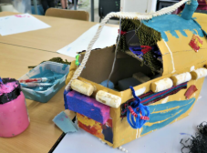 | 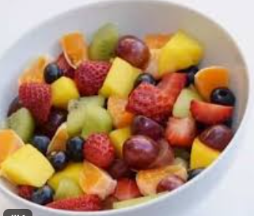 | 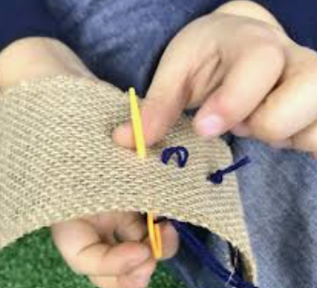
Year 1 / 2 CYCLE A / B
 |  | Autumn Term |  | Spring Term |  | Summer Term
 |  | Cycle A | Cycle B | Cycle A | Cycle B | Cycle A | Cycle B
 |  | Mechanisms: Wheels and  axels (5 Lessons)  https://www.kapowprimary  .com/subjects/design-technology/key-stage-1/year-1/option-1-wheels-and-axles/ | Structures: A chair (for a bear4  lessons)  https://www.  kapowprimary.com/subjects/design-technology/key-stage-1/year-2/structures/structures-a-chair-for-a-bear/ | Structures: Constructing a  Fairground wheel (4 Lessons)  https://  www.kapowprimary.com  /subjects/design-technology/key-stage-1/year-2/new-mechanisms-fairground-wheel/ | Food: A balanced diet  (4 lessons)  https://  www.  Kapow  primary.com/subjects/design-technology/key-stage-1/year-2/cooking-and-nutrition-balanced-diet/ | Food: cooking and nutrition (6  lessons)  https://www.  kapowprimary.com/subjects/design-technology/key-stage-1/year-1/cooking-and-nutrition-smoothies/ | Mechanisms: Making a matching slider game book (5 lessons)  https://  www.kapowprimary.com/subjects/design-technology/key-stage-1/year-1/mechanisms/mechanisms-matching-slider-game/
Skills | Design | Talk about existing products when generating ideas.  Stating what they intend to make and why – identifying a purpose  Use basic drawing skills to communicate ideas | Generating and communicating ideas using sketching and modelling. Learning about different types of structures, found in the natural world and in everyday objects. | Learning the importance of a clear design criteria. Including individual preferences and requirements in a design | Designing three wrap ideas. | Designing smoothie carton packaging by-hand. Learning where and how fruits and vegetables grow. | Explaining how to adapt mechanisms, using bridges or guides to control the movement. Designing a moving story book for a given audience.
Skills | Make | Choosing between a number of materials  Puncturing holes  Using tools like scissors to create shapes  Finding the middle of an object | Making a structure according to design criteria. Creating joints and structures from paper/card and tape. Building a strong and stiff structure by folding paper. | Making stable structures from card. Following instructions to cut and assemble the supporting structure of a windmill. Making functioning turbines and axles which are assembled into a main supporting structure. Finding the middle of an object. Puncturing holes. Adding weight to structures. Creating supporting structures. Cutting evenly and carefully | Chopping foods safely to make a wrap. Constructing a wrap that meets a design brief. Grating foods to make a wrap. Snipping smaller foods instead of cutting. Spreading soft foods to make a wrap. Identifying the five food groups. Learning about balanced diet. | Chopping fruit and vegetables safely to make a smoothie. Juicing fruits safely to make a smoothie. Identifying if a food is a fruit. | Following a design to create moving models that use levers and sliders.
Skills | Evaluate | Comparing two products and discussing what is best for purpose  Comparing their finished products with their original designs | Exploring the features of structures. Comparing the stability of different shapes. Testing the strength of own structures. Identifying the weakest part of a structure. Evaluating the strength, stiffness and stability of own structure. | Evaluating a windmill according to the design criteria, testing whether the structure is strong and stable and altering it if it isn’t. Suggest points for improvements. | Describing appearance, smell and taste. Taste and evaluating different food combinations. Describing the information that should be included on a label. | Tasting and evaluating different food combinations. Describing appearance, smell and taste. Suggesting information to be included on packaging. Comparing their own smoothie with someone else’s. | Testing a finished product, seeing whether it moves as planned and if not, explaining why and how it can be fixed. Reviewing the success of a product by testing it with its intended audience.
Skills | Technical Knowledge | Recognising and exploring everyday objects that have mechanisms | I know that shapes and structures with wide, flat bases or legs are the most stable. I know that the shape of a structure affects its strength. I know that materials can be manipulated to improve strength and stiffness. I know that a structure is something which has been formed from parts. I know that a ‘stiff’ structure or material is one which does not bend easily. | I know that cylinders are a strong type of structure. I know that axles are used in structures and mechanisms to make parts turn in a circle. I know that a structure is something that has been made and put together. I know that the sails or blades of a windmill are moved by the wind. To know that stable structures do not topple. | I know that ‘diet’ means the food and drink that a person or animal usually eats.  I know what makes a balanced diet. I know the five main food groups are: Carbohydrates, fruits and vegetables, protein, dairy and foods high in fat and sugar I know that ‘ingredients’ means the items in a mixture or recipe. | To know that a blender is a machine which mixes ingredients together into a smooth liquid. To know that a fruit has seeds and a vegetable does not. To know that fruits grow on trees or vines. To know that vegetables can grow either above or below ground. To know that vegetables is any edible part of a plant. | To know that a mechanism is the parts of an object that move together. To know that a slider mechanism moves an object from side to side. To know that a slider mechanism has a slider, slots, guides and an object. To know that bridges and guides are bits of card that purposefully restrict the movement of the slider.
Skills | Key vocabulary | Axle, mechanism, turn, product, design, evaluate | Properties, shape, structure, stable, test, model, | Rotate, equal, rotor blades, base, sails, centre | Balanced, chopping board, diet, carbohydrate, protein, dairy | Recipe, ingredients, blend, juice, healthy, seed | Mechanism, sliders,  Assemble, adapt, input, model
Knowledge |  | I know that many things that move have parts inside that help them move  I know that an axle allows the wheel to turn without falling off | - I know that the chair I design needs to be strong, stiff, stable and support Teddy.  - I know how create joints and structures.  - according to the design criteria. | - I know how to widen a hole.  - I know how to join parts together.  - I know how to attach a supporting structure. | - I know how to select the ingredients for my recipe.  - I know how to identify the equipment needed to prepare different foods.  - I know to decide if I like different wraps and choose my favourite. | - I know how to gather the ingredients for a simple recipe.  - I know how to cut and juice fruits as part of a recipe.  - I know how to use my senses to compare my smoothie with my partner’s. | - I know that sliders are mechanisms.  - I know how to identify the sliders and how to make things move.  - I know how to create moving models that use sliders.  - I know how to use the words up, down, left and right to describe movement.
Link to National Curriculum |  | Design: Design purposeful, functional, appealing products for themselves and other users based on design criteria  Make: select from and use a range of tools and equipment to perform practical tasks [for example, cutting, shaping, joining and finishing]  Evaluate: explore and evaluate a range of existing products  Evaluate their ideas and products against design criteria
Examples |  | 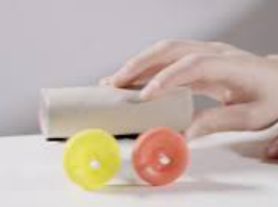 | 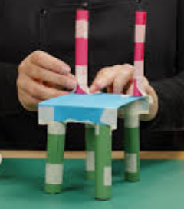 | 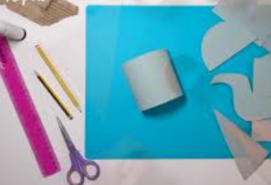 | 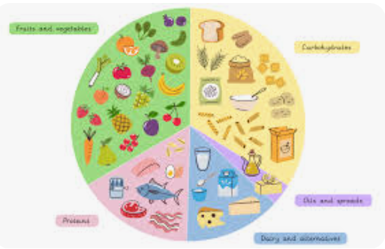 | 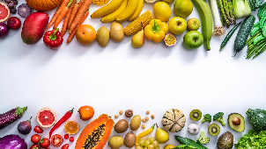 | 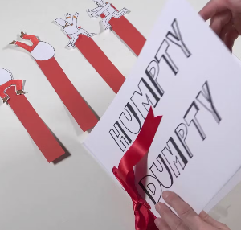

Year 3 / 4 Cycle A/B
 |  | Autumn Term |  |  |  | Spring Term |  |  |  | Summer Term
 |  | Cycle A |  | Cycle B |  | Cycle A |  | Cycle B |  | Cycle A |  | Cycle B
 |  | Structures: Constructing a castle (4 Lessons)  https://www.  kapowprimary.com/  subjects/design-technology/key-stage-2/year-3/structures/structures-constructing-a-castle/lesson-4-building-a-castle/ |  | Textiles: Fastening (4 Lessons)  https://www.  kapowprimary.com/  subjects/design-technology/key-stage-2/year-4/textiles-fastenings/ |  | Mechanical Systems : Pneumatic toys (5 Lessons)  https://  www.  kapowprimary.  com/subjects/design-technology/key-stage-2/year-3/new-mechanical-systems-pneumatic-toys/ |  | Electrical System: Torches (4 Lessons)  https://  www.  Kapowprimary  .com/  subjects/design-technology/key-stage-2/year-4/electrical-systems-torches/ |  | Textiles: Egyptian Collars (4 Lessons)  https:/  /www.  Kapowprimary  .com/subjects/design-technology/key-stage-2/year-3/textiles-cushions-or-egyptian-collars/textiles-egyptian-collars/ |  | Food: adapting a recipe (6Lessons)  https://  www.  Kapow  primary.com/  subjects/design-technology/key-stage-2/year-4/new-cooking-and-nutrition-adapting-a-recipe/
Skills | Design | Designing a castle with key features to appeal to a specific person/purpose. Drawing and labelling a castle design using 2D shapes, labelling: -the 3D shapes that will create the features - materials needed and colours. Designing and/or decorating a castle tower on CAD software. |  | Writing design criteria for a product, articulating decisions made. Designing a personalised book sleeve. |  | Designing a toy which uses a pneumatic system. Developing design criteria from a design brief. Generating ideas using thumbnail sketches and exploded diagrams. Learning that different types of drawings are used in design to explain ideas clearly. |  | Designing a torch, giving consideration to the target audience and creating both design and success criteria focusing on features of individual design ideas. |  | Designing and making a template from an existing cushion and applying individual design criteria. |  | Designing a biscuit within a given budget. Conducting market research.
Skills | Make | Constructing a range of 3D geometric shapes using nets . Creating special features for individual designs. Making facades from a range of recycled materials. |  | Making and testing a paper template with accuracy and in keeping with the design criteria. Measuring, marking and cutting fabric using a paper template. Selecting a stitch style to join fabric. Working neatly by sewing small, straight stitches. Incorporating a fastening to a design. |  | Creating a pneumatic system to create a desired motion. Building secure housing for a pneumatic system. Using syringes and balloons to create different types of pneumatic systems to make a functional and appealing pneumatic toy. Selecting materials due to their functional and aesthetic characteristics. Manipulating materials to create different effects by cutting, creasing, folding and weaving. |  | Making a torch with a working electrical circuit and switch. Using appropriate equipment to cut and attach materials. Assembling a torch according to the design and success criteria. |  | Following design criteria to create a cushion or Egyptian collar. Selecting and cutting fabrics with ease using fabric scissors Threading needles with greater independence. Tying knots with greater independence. Sewing cross stitch to join fabric. Decorating fabric using appliqué. Completing design ideas with stuffing and sewing the edges (Cushions) or embellishing the collars based on design ideas (Egyptian collars). |  | Following a baking recipe. Understanding safety and hygiene rules. Adapting a recipe.
Skills | Evaluate | Evaluating own work and the work of others based on the aesthetic of the finished product and in comparison, to the original design. Suggesting points for modification of the individual designs. |  | Testing and evaluating an end product against the original design criteria. Deciding how many of the criteria should be met for the product to be considered successful. Suggesting modifications for improvement. Articulating the advantages and disadvantages of different fastening types. |  | Using the views of others to improve designs. Testing and modifying the outcome, suggesting improvements. Understanding the purpose of exploded-diagrams through the eyes of a designer and their client. |  | Evaluating electrical products. Testing and evaluating the success of a final product. |  | Evaluating an end product and thinking of other ways in which to create similar items. |  | Evaluating an adapted recipe. Evaluating and comparing a range of products. Suggesting modifications.
Skills | Technical Knowledge | I know that wide and flat based objects are more stable. I know the importance of strength and stiffness in structures. |  | I know that a fastening is something which holds two pieces of material together for example a zipper, toggle, button, press stud and Velcro. I know that different fastening types are useful for different purposes. I know that creating a mock up (prototype) of their design is useful for checking ideas and proportions. |  | I know how pneumatic systems, work. I know that pneumatic systems can be used as part of a mechanism. I know that pneumatic systems operate by drawing in, releasing and compressing air. |  | I know that electrical conductors are materials which electricity can pass through. I know that electrical insulators are materials which electricity cannot pass through. I know that a battery contains stored electricity that can be used to power products. I know that an electrical circuit must be complete for electricity to flow. I know that a switch can be used to complete and break an electrical circuit. |  | I know that applique is a way of mending or decorating a textile by applying smaller pieces of fabric to larger pieces. I know that when two edges of fabric have been joined together it is called a seam. I know that it is important to leave space on the fabric for the seam. I understand that some products are turned inside out after sewing so the stitching is hidden. |  | I know that the amount of an ingredient in a recipe is known as the ‘quantity.’ I know that safety and hygiene are important when cooking. I know the following cooking techniques: sieving, measuring, stirring, cutting out and shaping. I know the importance of budgeting while planning ingredients for a recipe. I know that products often have a target audience.
Skills | Key vocabulary | 2D,3D, scoring, shape, stable, strong, stiff |  | Criteria, fabric, fastening, stitch, mock-up, template |  | Housing, linkage, pivot, evaluate, thumbnail sketch, diagram |  | Battery, bulb, buzzer, circuit diagram, component, conductor |  | asymmetrical, appliqué, cross-stitch, embellish, patch, symmetrical |  | adapt, appearance, ingredients, modify, market research, buttery
Knowledge |  | I know that wide and flat based objects are more stable. I know the importance of strength and stiffness in structure. I know that the façade is the front of the structure. I know the features of the castles; flags, towers, battlements, turrets, curtains wall, moat, drawbridge and gatehouse. |  | I know that fastening holds two pieces of material together.  I know that different types of fastening are useful for different purposes. I know that creating a prototype is useful for checking ideas and proportions. |  | - I know that a mechanical system can allow us to move something more easily. I know that Pivots can be used to create more movement in a mechanical system. I know that Mechanical systems can have more than one mechanism that moves to make them work. |  | I know that electrical conductors are materials which electricity can pass through. I know that electrical insulators are materials that electricity cannot pass through.  I know that a battery contains stored electricity that can be used to power products.  I know that an electrical circuit must be complete for electricity to flow. I know that a switch can be used to complete or break an electrical circuit. |  | I know that applique is a way of mending or decorating a textile. I know some materials and I can explain their aesthetic and functional properties. |  | I know that the amount of an ingredient in a recipe is known as the ‘quantity’. I know that safety and hygiene are important when cooking.  - I know the following cooking techniques: sieving, measuring, mixing/stirring, cutting out and shaping. I know  - The importance of budgeting while planning ingredients for a recipe. I know  - that products often have a target audience.
Link to National Curriculum |  | Design:  Use research and develop design criteria to inform the design of innovative, functional, appealing products that are fit for purpose, aimed at particular individuals or groups, generate, develop, model and communicate their ideas through discussion, annotated sketches, cross-sectional and exploded diagrams, prototypes, pattern pieces and computer-aided design  Make:  select from and use a wider range of tools and equipment to perform practical tasks [for example, cutting, shaping, joining and finishing], accurately select from and use a wider range of materials and components, including construction materials, textiles and ingredients, according to their functional properties and aesthetic qualities  Evaluate:  investigate and analyse a range of existing products evaluate their ideas and products against their own design criteria and consider the views of others to improve their work understand how key events and individuals in design and technology have helped shape the world.  Technical knowledge:  apply their understanding of how to strengthen, stiffen and reinforce more complex structures understand and use mechanical systems in their products [for example, gears, pulleys, cams, levers and linkages] understand and use electrical systems in their products [for example, series circuits incorporating switches, bulbs, buzzers and motors] apply their understanding of computing to program, monitor and control their products.  Cooking and nutrition:  understand and apply the principles of a healthy and varied diet prepare and cook a variety of predominantly savoury dishes using a range of cooking techniques understand seasonality, and know where and how a variety of ingredients are grown, reared, caught and processed.
Examples |  | 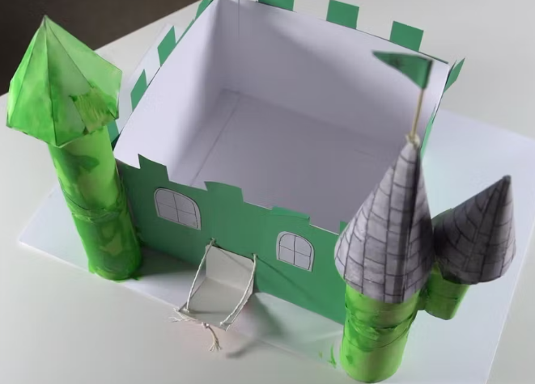 | 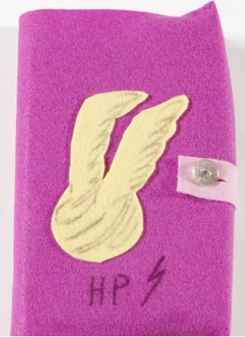 |  | 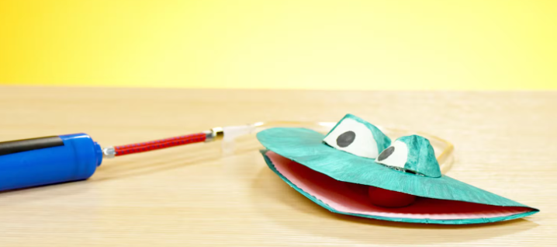 |  | 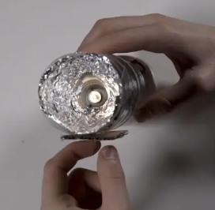 |  | 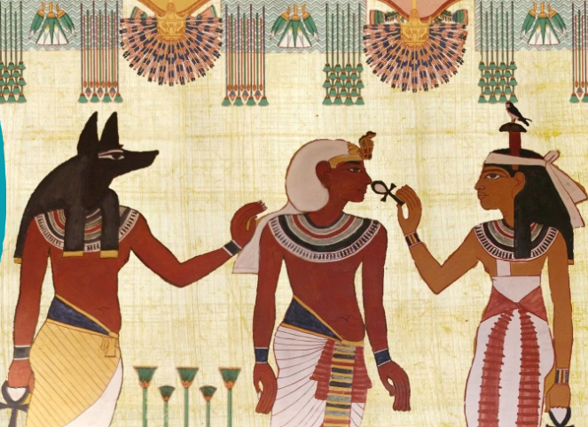 |  | 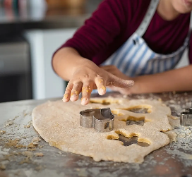

Year 5 / 6 Cycle A/B
 |  | Autumn Term |  |  |  | Spring Term |  |  |  | Summer Term
 |  | Cycle A |  | Cycle B |  | Cycle A |  | Cycle B |  | Cycle A |  | Cycle B
 |  | Yr5-Structure: Playground pioneers  (5 Lessons)  https://  www.  Kapow  primary.com/  subjects/design-technology/  key-stage-2/year-6/structures/  structures-playground-pioneers/ |  | Yr6- Textiles:  Waistcoats (4 Lessons)  https://  www.  Kapow  primary.  com/  subjects/design-technology/key-stage-2/year-6/textiles/textiles-waistcoats/ |  | Yr5- Mechanical system: Gears and Pulleys (5 Lessons)  https://  www.  kapowprimary.  com/subjects/  design-technology/key-stage-2/year-5/gears-and-pulleys/ |  | Yr6- Electrical System: Wobble bots (5 Lessons)  https://  www.  Kapow  primary.  com/  subjects/design-technology/key-stage-2/year-5/electrical-systems/electrical-systems-wobble-bots/ |  | Yr6- Electrical System: Steady Hand Game (4 Lessons)  https://  www.  kapowprimary.  com/subjects/  design-technology/key-stage-2/year-6/electrical-systems-steady-hand-game/ |  | Yr6- Food: Come dine with me (6 Lessons)  https://  www.  Kapow  primary.com/  subjects/  design-technology/key-stage-2/year-6/new-cooking-and-nutrition-come-dine-with-me/
Skills | Design | Designing a playground featuring a variety of different structures, considering how the structures will be used, considering effective and ineffective designs. |  | Designing a waistcoat in accordance to a specification linked to set of design criteria. Annotating designs, to explain their decisions |  | Noticing wider-reaching problems or needs in the community. Identifying a wide range of needs and potential barriers through market research. Writing more complex problem statements that consider multiple factors and constraints. Creating more complex design criteria that require considering detailed user needs, environmental impact, materials and cost. Coming up with a broader range of ideas and deeper innovation, requiring pupils to think critically about their ideas' practicality and originality. Beginning to use more complex annotated sketches, such as cross-sectional and exploded diagrams and pattern pieces in design. Using a series of prototypes to refine and improve their designs |  | Creating more complex design criteria that require considering detailed user needs, environmental impact, materials and cost. Developing more independence in generating ideas. Coming up with a broader range of ideas and deeper innovation, requiring pupils to think critically about their ideas' practicality and originality. Using a series of prototypes to refine and improve their designs. |  | Designing a steady hand game - identifying and naming the components required. Drawing a design from three different perspectives. Generating ideas through sketching and discussion. Modelling ideas through prototypes. Understanding the purpose of products (toys), including what is meant by ‘fit for purpose’ and ‘form over function’ |  | Writing a recipe, explaining the key steps, method and ingredients. Including facts and drawings from research undertaken.
Skills | Make | Building a range of play apparatus structures drawing upon new and prior knowledge of structures. Measuring, marking and cutting wood to create a range of structures. Using a range of materials to reinforce and add decoration to structures. |  | Using a template when cutting fabric to ensure they achieve the correct shape. Using pins effectively to secure a template to fabric without creases or bulges. Marking and cutting fabric accurately, in accordance with their design. Sewing a strong running stitch, making small, neat stitches and following the edge. Tying strong knots. Decorating a waistcoat, attaching features (such as appliqué) using thread. Finishing the waistcoat with a secure fastening (such as buttons). Learning different decorative stitches. Sewing accurately with evenly spaced, neat stitches. |  | Consistently apply safety instructions. Select appropriate scissors to handle delicate cutting tasks and challenging materials. Cutting patterns and drawings accurately. In supervised groups, using hot glue guns safely. Recognising that hot glue is useful for joining materials that need a strong bond that sets quickly. Choosing PVA glue over hot glue for its safety when joining materials in less intensive projects. |  | Producing lists of equipment, materials and tools that they need for a task. Creating a step-by-step plan for making. Selecting materials, components or ingredients based on research or user needs. Explaining their choices, referring to their research. Understanding and explaining the importance of each safety rule. Consistently apply safety instructions. Balancing aesthetics and functionality when creating parts of a design. Considering when best to apply finishing effects. |  | Constructing a stable base for a game. Accurately cutting, folding and assembling a net. Decorating the base of the game to a high-quality finish. Making and testing a circuit. Incorporating a circuit into a base. |  | Following a recipe, including using the correct quantities of each ingredient. Adapting a recipe based on research. Working to a given timescale. Working safely and hygienically with independence.
Skills | Evaluate | Improving a design plan based on peer evaluation. Testing and adapting a design to improve it as it is developed. Identifying what makes a successful structure. |  | Reflecting on their work continually throughout the design, make and evaluate process. |  | Reflecting on the usability, aesthetics, innovation and sustainability of products and discussing how design choices impact these aspects. Assessing their designs against a more complex set of design criteria that includes functionality, aesthetics, user experience, sustainability and cost. Considering alternative materials, tools or techniques that could enhance the product. Providing feedback that is helpful, specific, and encouraging. Incorporating feedback from peers or users improve their product further, explaining the changes they made and the impact they had |  | Reflecting on the usability, aesthetics, innovation and sustainability of products and discussing how design choices impact these aspects. Assessing their designs against a more complex set of design criteria that includes functionality, aesthetics, user experience, sustainability and cost. Considering alternative materials, tools or techniques that could enhance the product. Providing feedback that is helpful, specific, and encouraging. Incorporating feedback from peers or users improve their product further, explaining the changes they made and the impact they had. |  | Testing own and others finished games, identifying what went well and making suggestions for improvement. Gathering images and information about existing children’s toys. Analysing a selection of existing children’s toys. |  | Evaluating a recipe, considering: taste, smell, texture and origin of the food group. Taste testing and scoring final products. Suggesting and writing up points of improvements when scoring others’ dishes, and when evaluating their own throughout the planning, preparation and cooking process. Evaluating health and safety in production to minimise cross contamination.
Skills | Technical Knowledge | I know that structures can be strengthened by manipulating materials and shapes. |  | To understand that it is important to design clothing with the client/ target customer in mind. To know that using a template (or clothing pattern) helps to accurately mark out a design on fabric. To understand the importance of consistently sized stitches |  | That mechanical systems that use gears in everyday objects (eg bicycle, clock). That gears and pulleys allow us to transfer movement and force from one part of a mechanical system to another. That gears allow us to increase the output of a mechanism. |  | Beginning to understand that electricity flows around a circuit. Using different components to produce different results from electrical systems. Creating working electrical circuits with a wider variety of electrical components. Deconstructing electrical systems to understand how they work. |  | To know that batteries contain acid, which can be dangerous if they leak. To know the names of the components in a basic series circuit, including a buzzer. |  | To know that ‘flavour’ is how a food or drink tastes. To know that many countries have ‘national dishes’ which are recipes associated with that country. To know that ‘processed food’ means food that has been put through multiple changes in a factory. To understand what happens to a certain food before it appears on the supermarket shelf (Farm to Fork).
Skills | Key vocabulary | Apparatus, cladding,  Criteria, equipment,  Landscape, features |  | Annotate, design criteria, fabric, target customer,  Waistcoat, waterproof |  | pulley system, gear system, problem statement, renewable energy, sustainability, force |  | assemble, electrical component, motor, battery, circuit, electricity |  | Conductor, bulb holder, copper,  insulator, gross motor skills, fine motor skills |  |  | enhance, bridge method, cross-contamination, farm to fork, flavours, storyboard
Knowledge |  | I know that structures can be strengthened by manipulating materials and shapes. I know what a footprint plan is. I know that prototype is a cheap model to test a design idea. |  | I know that using a template helps to accurately mark out a design, on a fabric. I know the importance of consistently sized stitches. |  | - I know that Gears and pulleys allow us to transfer movement and force from one part of a mechanical system to another. I know that Sustainability means thinking about the materials that were used to make a product and how the product was made. I know that Market research is a way of collecting information about problems or needs. |  | - I know that Improving on prototypes can help to improve the final design. I know that the shape of an object can affect both its aesthetics and function. I know that an electric motor converts electricity into rotational movement. |  | - I know the difference between ‘form’ and ‘function’. I know that ‘form over purpose’ means that a product looks good but does not work very well. |  |  | I know that ‘flavour’ is how a food or drink tastes. I know that many countries have ‘national dishes’ which are recipes associated with that country. I know that ‘processed food’ means food that has been put through multiple changes in a factory. I know what happens to a certain food before it appears on the supermarket shelf (farm to fork).
Link to National Curriculum |  | Design:  Use research and develop design criteria to inform the design of innovative, functional, appealing products that are fit for purpose, aimed at particular individuals or groups, generate, develop, model and communicate their ideas through discussion, annotated sketches, cross-sectional and exploded diagrams, prototypes, pattern pieces and computer-aided design  Make:  select from and use a wider range of tools and equipment to perform practical tasks [for example, cutting, shaping, joining and finishing], accurately select from and use a wider range of materials and components, including construction materials, textiles and ingredients, according to their functional properties and aesthetic qualities  Evaluate:  investigate and analyse a range of existing products evaluate their ideas and products against their own design criteria and consider the views of others to improve their work understand how key events and individuals in design and technology have helped shape the world.  Technical knowledge:  apply their understanding of how to strengthen, stiffen and reinforce more complex structures understand and use mechanical systems in their products [for example, gears, pulleys, cams, levers and linkages] understand and use electrical systems in their products [for example, series circuits incorporating switches, bulbs, buzzers and motors] apply their understanding of computing to program, monitor and control their products.  Cooking and nutrition:  understand and apply the principles of a healthy and varied diet prepare and cook a variety of predominantly savoury dishes using a range of cooking techniques understand seasonality, and know where and how a variety of ingredients are grown, reared, caught and processed.
Examples |  | 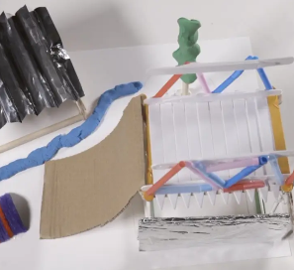 | 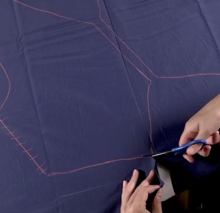 |  | 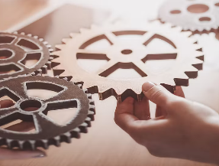 |  | 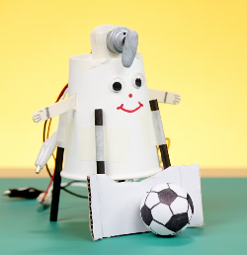 |  | 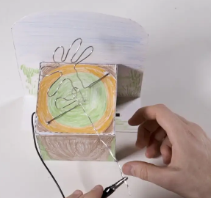 |  | 